Format of Question paper for Midsemester Examination

Birla Institute of Technology & Science, Pilani
Work Integrated Learning Programmes Division
Second Semester 2024-2025

Regular Examination
(EC-2 Regular)

SOLUTION

Course No. : AIMLCLZG513
Course Title : Advanced Deep Learning
Nature of Exam : Closed Book
Weightage : 30%
No. of Pages = 2

No. of Questions = 3
Duration :
Date of Exam :
Note to Students:
- Please follow all the Instructions to Candidates given on the cover page of the answer book.
- All parts of a question should be answered consecutively. Each answer should start from a fresh page.
- Assumptions made if any, should be stated clearly at the beginning of your answer.

Q.1. [1.5+1+1+4.5=8 Marks]

Consider a fully connected autoencoder (each hidden node is connected to all inputs and all outputs) with two-dimensional one-hot input and one hidden layer with ReLU activation function. At iteration t, the weights are shown in the following autoencoder architecture along with the one-hot encoded input vector (x1=1, x2=0). All bias values are zero. Assume learning rate = 0.25 and momentum constant = 0.75. Also assume at t-1, w1= -0.5, w2=0.5, w3=0.5 and w4= -0.5.

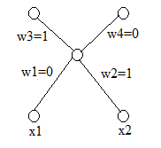
- What activation function will you choose at the output node?
- What loss function will you choose for training this autoencoder?
- What will be the value of loss function at iteration t?
- What will be the weights w1 and w3 in iteration t+1 assuming backpropagation with ordinary gradient descent is used?

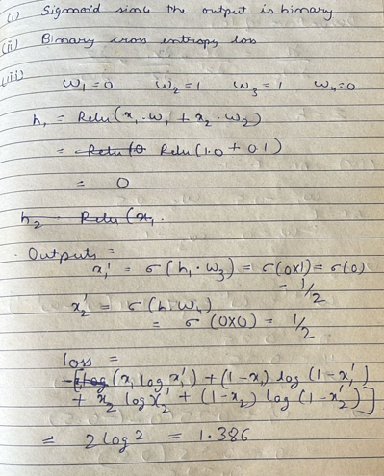
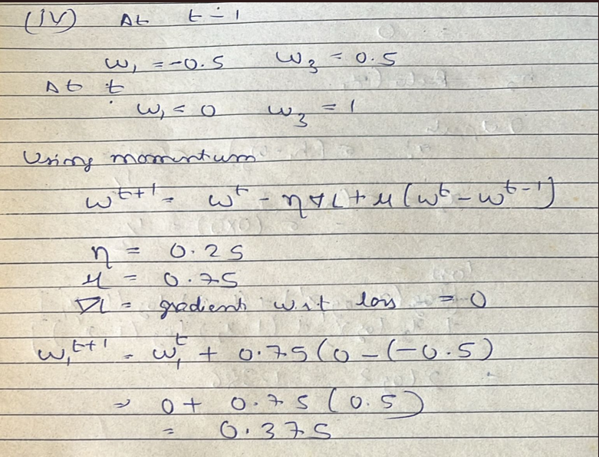
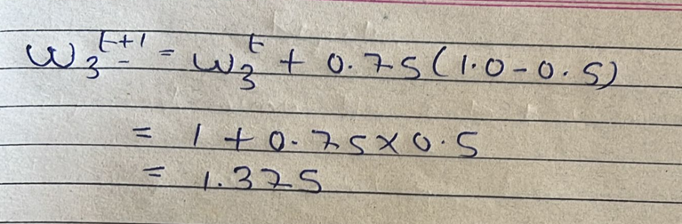

Q.2. [2.5+2.5=5 marks]

Recall, Laplace distribution is given by
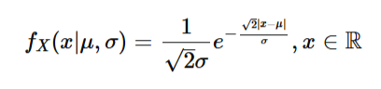
If data instances {2, 1, 0, -1, -3} are obtained via sampling the above distribution, find the maximum likelihood estimate of (μ, σ).

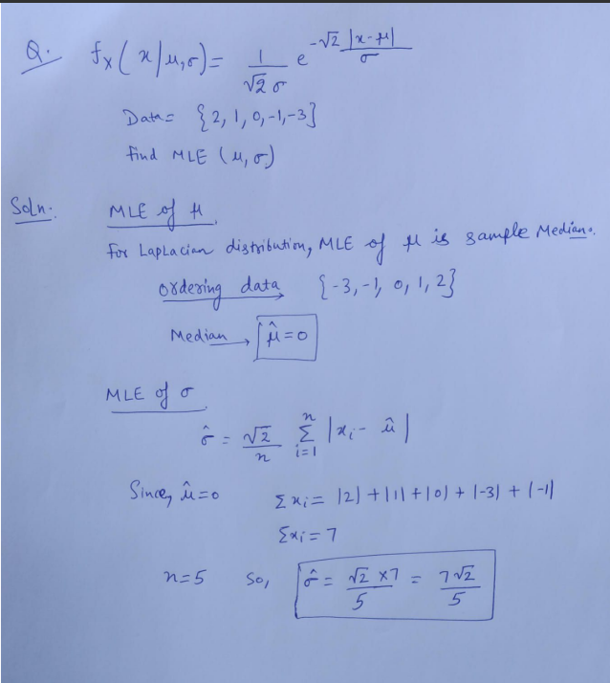

Q.3. [3+2+3=9 marks]

- Calculate the inverse and determinant of
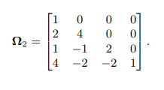
- Consider transforming a uniform base density defined on z ∈ [0, 1] using the function x = f[z] = z² is a flow model. Find an expression for the transformed distribution Pr(x).

- Are the following functions invertible or not? Why?
- z=f(x)=x³ – x⁵ + 2x⁷
- z=f(x)=exp(-|x|)
- z=f(x)=x² – x

A.
Determinant of
Since is a lower triangular matrix, its determinant is the product of its diagonal entries.
So, the determinant of is 8.
Inverse of
The inverse of will be found using the adjugate method, where 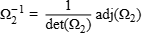. Alternatively, the inverse could be found using the row reduction method by augmenting the matrix with the identity matrix and row reducing.
Steps (using adjugate method):
  - Find the cofactor matrix: The cofactor is found by , where is the minor matrix obtained by removing the -th row and -th column.
Steps to find the inverse of a matrix using the adjugate matrix:
Calculate the cofactors: For each element in the matrix, calculate its cofactor. The cofactor is given by times the determinant of the submatrix obtained by removing the -th row and -th column.
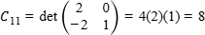and 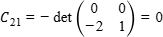.
Form the adjugate matrix: The adjugate matrix, denoted as , is the transpose of the cofactor matrix, i.e., .
the determinant is given as 8.
Calculate the inverse: Divide each element of the adjugate matrix by the determinant of the original matrix.
Answer (Inverse of ):

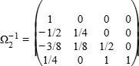
B.
The uniform density on is .
The transformation is , so .
The derivative 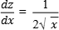.
The transformed distribution is .

Substituting the values, 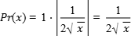.

The range for is since .
c.

- f(x)=x³ – x⁵ + 2x⁷
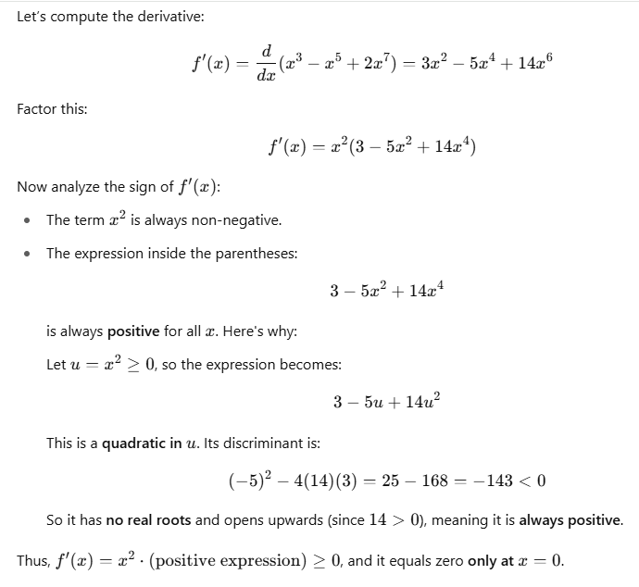
ii)
Function 2: .
  - This function is not one-to-one because, for example, and . Therefore, it is not invertible.
iii)
Function 3: .
  - This function is not one-to-one because, for example, and . Therefore, it is not invertible.

The function is stated to be invertible, while and are not invertible.

Q.4. [2+5+1=8 Marks]

- What advantages PixelSNAIL offer over PixelCNN++ and how?

B. Assume the following MADE is used to calculate p(x₁), p(x₂|x1), p(x₃|x₂, x₁). x_{t} is the data value at time t and x1 arrives first and so on as shown on the figure. All node numbering is given. Type B (aka Type 2) mask is used in the output layer, and Type A (aka Type 1) masks are used in rest of the layers.
- Design all the necessary masks and show the final connections for the above MADE. Show all steps.
- What are the training parameters associated with output node 1?
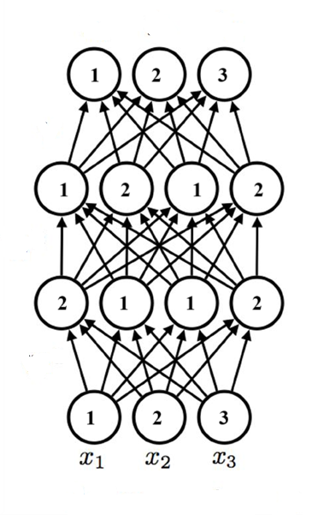
- Advantages of PixelSNAIL over PixelCNN++
- Improved Long-Range Dependency Modeling
  - PixelSNAIL incorporates self-attention along with convolutions, enabling it to better model long-range dependencies in images compared to PixelCNN++, which relies only on masked convolutions.
- Causal Attention Mechanism
  - PixelSNAIL introduces a causal attention block that respects the autoregressive nature of pixel generation, enhancing the model's ability to condition each pixel on a wider and more relevant context.
- Better Sample Quality
  - Empirically, PixelSNAIL generates higher quality samples and achieves lower bits-per-dimension than PixelCNN++, reflecting improved likelihood modeling.
- By fusing masked convolutions with causal self-attention, PixelSNAIL enables both local and global context modeling in a single framework, something PixelCNN++ lacks.

- i)
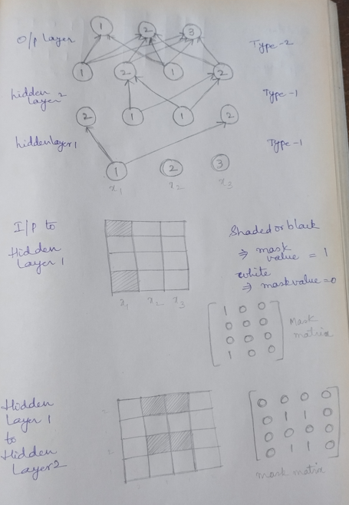
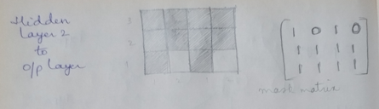

ii) 3 = 2 (weights from the two node 1 of the hidden layer 2) + 1 (bias)

